**1BM18CS089**

**SAHANA L**

**QUERIES**

**CREATE TABLE ORDER_ITEM(**

**ORDER_NO NUMBER(10),ITEM_NO NUMBER(10),QTY NUMBER(10),**

**PRIMARY KEY(ORDER_NO,ITEM_NO),**

**FOREIGN KEY(ORDER_NO) REFERENCES ORDERS(ORDER_NO)ON DELETE CASCADE,**

**FOREIGN KEY(ITEM_NO) REFERENCES ITEM(ITEM_NO) ON DELETE CASCADE);**

**DESC CUSTOMERS;**

**DESC ORDERS;**

**DESC ITEM;**

**DROP TABLE ORDERS;**

**CREATE TABLE WAREHOUSE(WAREHOUSE_NO NUMBER(10),CITY VARCHAR2(20),PRIMARY KEY(WAREHOUSE_NO));**

**DROP TABLE SHIPMENT;**

**DROP TABLE WAREHOUSE;**

**CREATE TABLE SHIPMENT(ORDER_NO NUMBER(10),WAREHOUSE_NO NUMBER(10), S_DATE DATE,**

**PRIMARY KEY(ORDER_NO,WAREHOUSE_NO),**

**FOREIGN KEY(ORDER_NO) REFERENCES ORDERS(ORDER_NO) ON DELETE CASCADE,**

**FOREIGN KEY(WAREHOUSE_NO) REFERENCES WAREHOUSE(WAREHOUSE_NO) ON DELETE CASCADE);**

**DROP TABLE SHIPMENT;**

**INSERT INTO CUSTOMERS VALUES(&CUST_NO,'&CNAME','&CITY');**

**SELECT * FROM CUSTOMERS;**

**INSERT INTO ORDERS VALUES(&ORDER_NO,'&ODATE',&CUST_NO,&ORDER_AMT);**

**SELECT * FROM ORDERS;**

**INSERT INTO ITEM VALUES(&ITEM_NO,&PRICE);**

**SELECT * FROM ITEM;**

**INSERT INTO ORDER_ITEM VALUES(&ORDER_NO,&ITEM_NO,&QTY);**

**SELECT * FROM ORDER_ITEM;**

**INSERT INTO WAREHOUSE VALUES(&WAREHOUSE_NO,'&CITY');**

**SELECT * FROM WAREHOUSE;**

**INSERT INTO SHIPMENT VALUES(&ORDER_NO,&WAREHOUSE_NO,'&DATE');**

**SELECT * FROM SHIPMENT;**

**DELETE FROM CUSTOMERS WHERE CUST_NO=1;**

**1.CUSTOMERS**

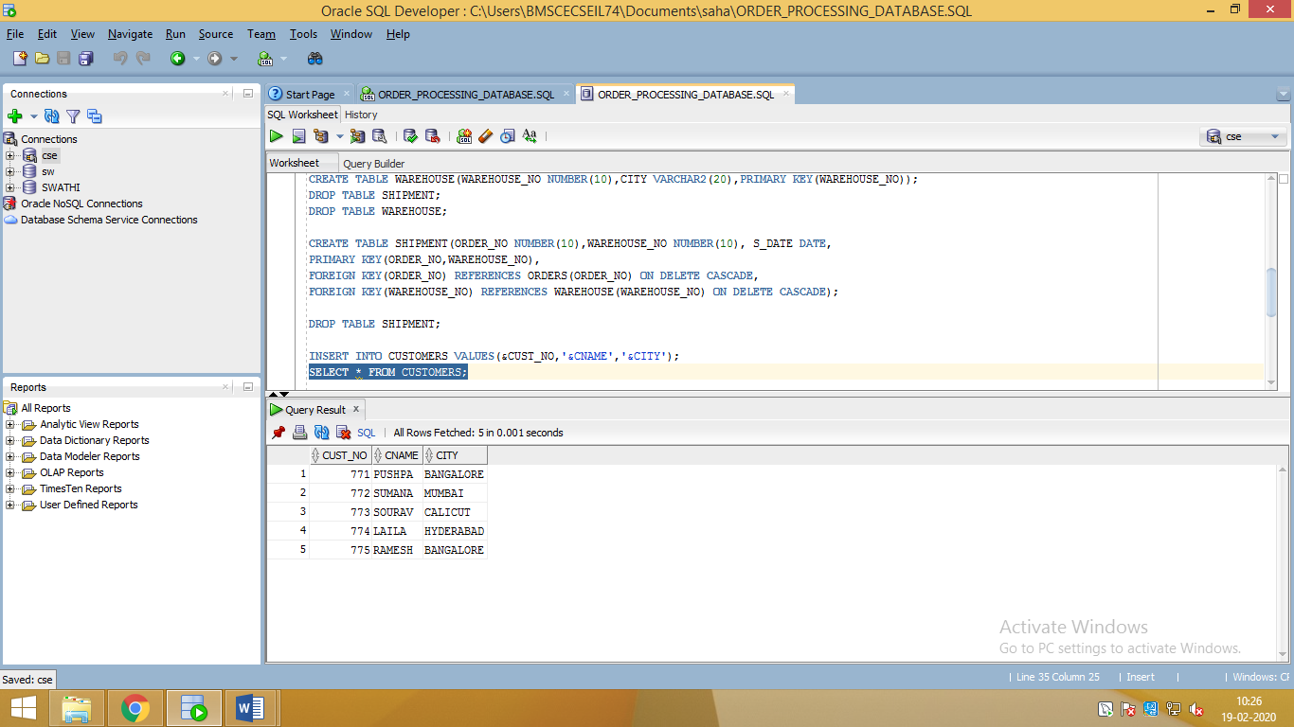

**2.ORDERS**

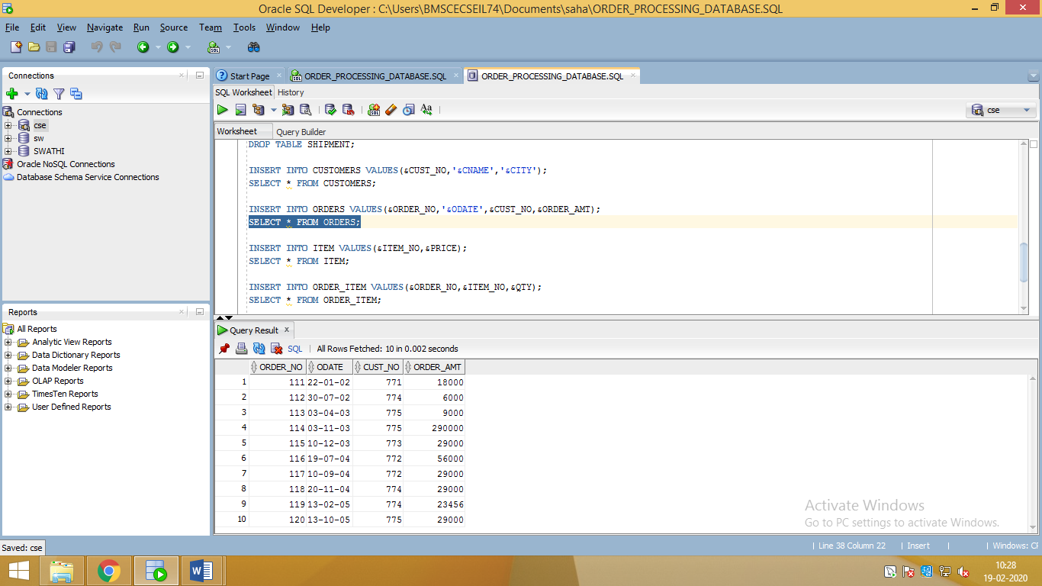

**3. ITEM**

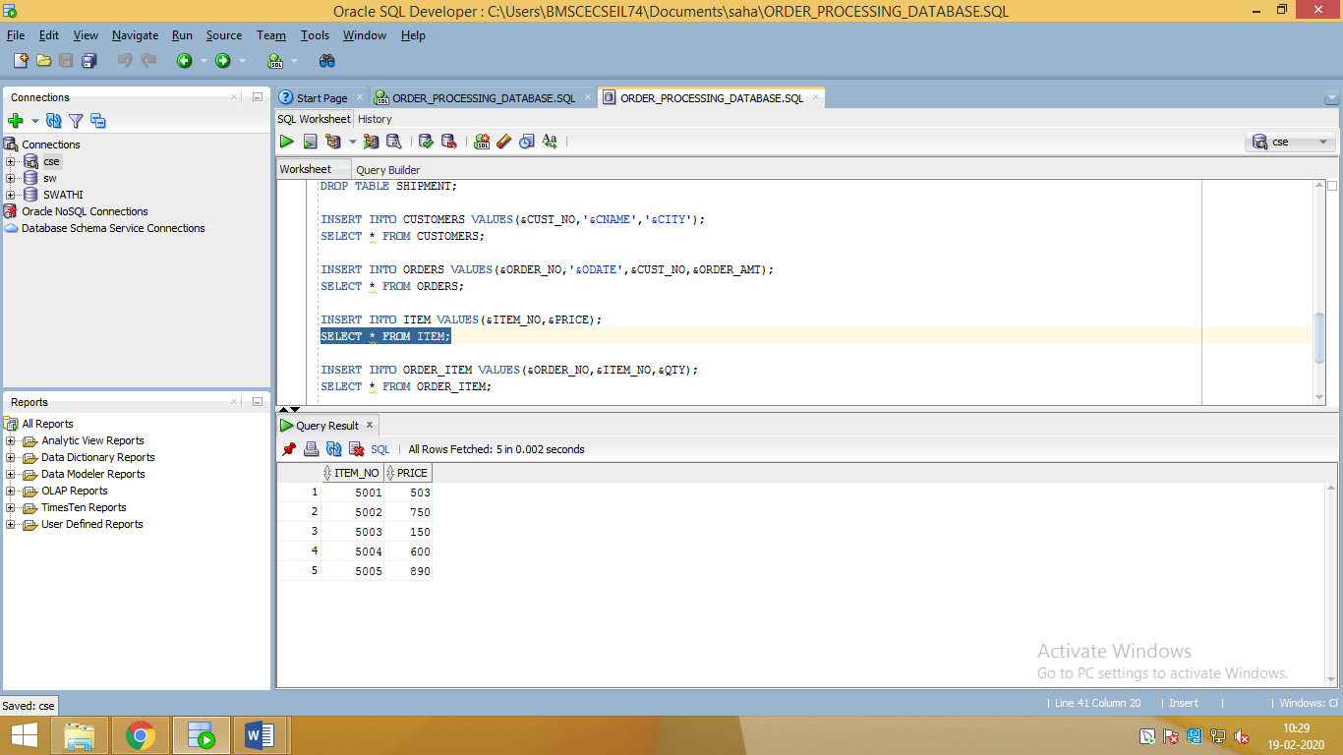

**4.ORDER ITEM**

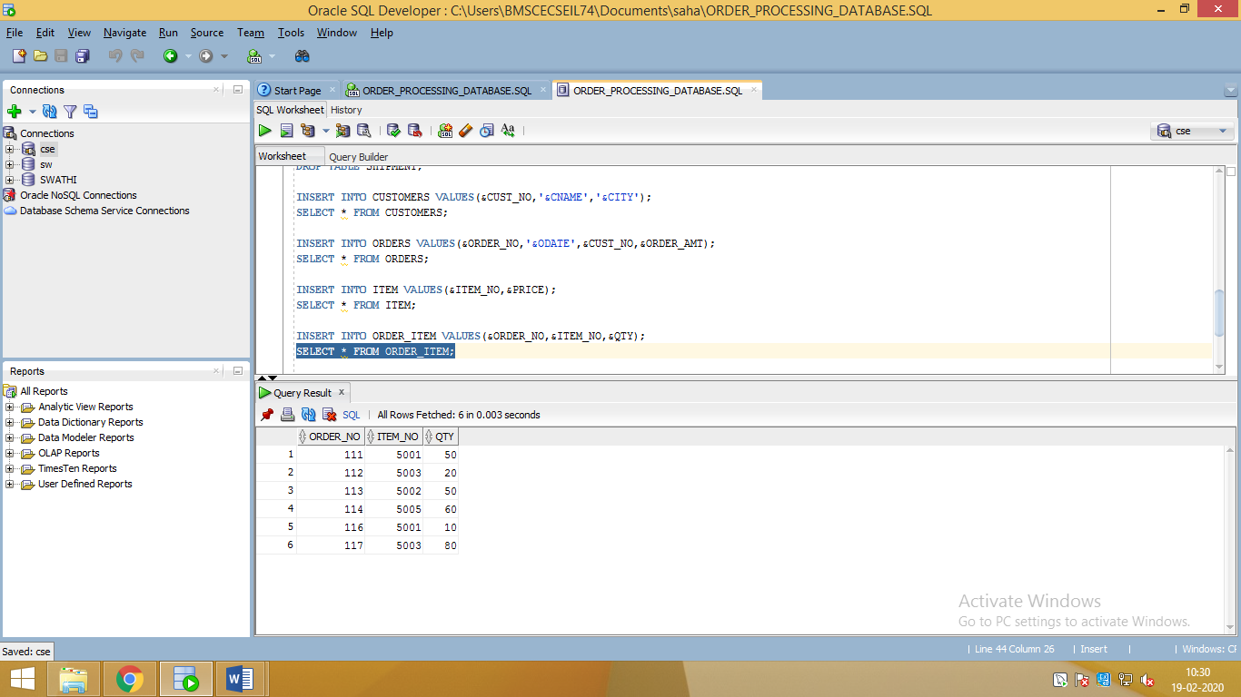

**5. WAREHOUSE**



**6. SHIPMENT**

